The InterPlanetary Superhighway
and the Origins Program

Martin W. Lo
Jet Propulsion Laboratory
California Institute of Technology
4800 Oak Grove Dr., 301/140L
Pasadena, CA 91109
Martin.Lo@jpl.nasa.gov
Halo Orbit Around Earth L₂ , Portal to the IPS

Moon

Earth’s IPS Approaching the Halo Orbit Portal

Tunnels of the Lunar IPS
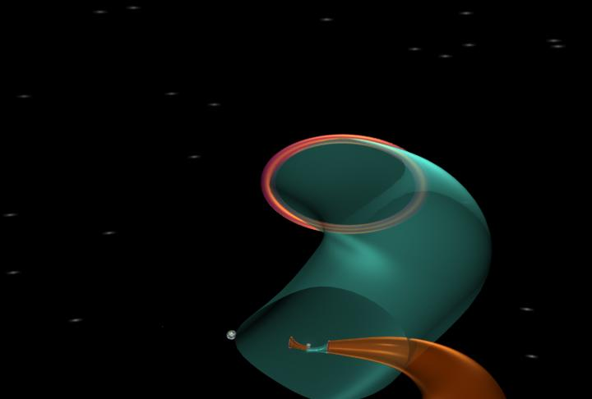

Earth

Lunar L₁ Halo Orbit

Lunar L₂ Halo Orbit

A Piece of Earth’s IPS
Figure 1. Artist’s conception of portions of the InterPlanetary Superhighway (IPS, tubes) of the Sun-Earth-Moon System generated by the halo orbits (large periodic orbits around the unstable Lagrange Points L₁, L₂, and L₃). Orbits on the blue-green tubes approach the halo orbits, while those on the red tubes go away from the halo orbits. Thus, the halo orbits are the portals, the literal “Highway Interchanges” to the Interplanetary Superhighway. The exploded view on the right is the Lunar portion of the Interplanetary Superhighway. Arrows indicate the direction of transport.

Abstract—The origin of the universe and of life itself have been central to human inquiries since the dawn of consciousness. To develop and use the technologies to answer these timeless and profound questions is the mission of NASA’s Origins Program. The newly discovered “InterPlanetary Superhighway” (IPS) by Lo and Ross [1], [2] is a significant and cost-effective technology that can contribute to both Origins’ Science and Technology Goals. IPS is a vast network of tunnels providing ultra-low energy transport throughout the entire Solar System, generated by the Lagrange Points of all of the planets and satellites. IPS contributes to Origins by providing: mission-enabling trajectories, human servicing of Origins missions, a new model of the Solar System, new techniques for detecting exo-planets, an important role in the development of life, and other scientific and engineering connections that impact the Origins Program. IPS is a critical technology for the Origins Program.

Table of Contents
- Introduction
- The InterPlanetary Superhighway
- IPS Trajectories Enable Origins Missions
- IPS Enables Human Service of Origins Missions
- IPS Model of the Solar System
- IPS Approach to Planet Detection
- IPS: The River of Life
- IPS and Science & Engineering
- Conclusion: IPS Is Critical to Origins

1. Introduction
The origin of the universe and of life itself have been central to human inquiry since the dawn of consciousness. Today, for the first time in history, we possess the technology to answer key aspects of these questions scientifically. We now can build powerful telescopes that can peer into the distant past of the primordial universe where it all began. We can focus on our neighboring star systems and see if they support life as our own Solar System. To develop the technology and use them to answer these timeless and profound questions of humanity are the goals of NASA’s Origins Program.

Amongst the myriad technology areas needed to achieve Origins’ goals, the newly discovered “InterPlanetary Superhighway” (IPS) by Lo and Ross [1], [2] is a significant and cost-effective technology that can contribute to both Origins’ Science and Technology goals. The InterPlanetary Superhighway is a vast network of tunnels and conduits providing ultra-low energy transport throughout the entire Solar System, generated by the Lagrange Points of all of the planets and satellites within the Solar System. Figure 1 shows an artist’s conception of a portion of the IPS in the Sun-Earth-Moon system. How does IPS support the Origins Program? Let us count the ways. (See subsequent sections for justification of statements and references.)

First, IPS contributes to the Origins Program in the many mission-enabling trajectories it provides. This includes the trajectories of Genesis, MAP, SIRTF, SIMS, StarLight, NGST, TPF, etc. Without the low-energy trajectories provided by IPS, from halo orbits (periodic orbits around the unstable Lagrange points) with ballistic Earth return to formation flight (in heliocentric or halo orbits), it is unclear how Origins missions would achieve their goals otherwise.

Second, IPS contributes to the Origins Program by enabling human servicing of many of its missions at locations currently not supported by the STS or the ISS. For example, the IPS conduits depicted in Figure 1 provides a family of ultra-low energy trajectories which enable human servicing of Earth libration missions such as TPF from a Lunar L₁ Gateway Habitat. Such Gateways can also be used to build large, thin film structures for solar sails or advanced telescopes which cannot be built on Earth. Hence, IPS will enable many new instruments and mission concepts yet to be conceived in support of the Origins Program.

Third, IPS contributes to the Origins Program by providing a new paradigm of the Solar System. This new theory views the Solar System as an integrated system in which every part is communicating with every other part — via the IPS. The motions of comets, asteroids, and zodiacal dust are under the influence and control of the IPS. Morphologies of structures within the Solar System at every scale from the giant circumstellar dust disk to the Kuiper and Asteroid Belts, to the rings around the outer planets, all of these have been shaped by the IPS. Thus IPS plays a significant role in the formation and evolution of solar systems which must be understood. All this can be achieved with just some paper, pencils, and computers! See Section 4 for justifications and references for these statements.

Fourth, IPS contributes to the Origins Program in the detection of extra-solar planets from their dynamical signatures in the circumstellar dust disk under IPS control. Using ground-based and space-based observations of circumstellar dust disks by precursor and first generation observatories such as Keck and NGST, potential terrestrial planets may be identified using IPS theory. The identification of these targets will greatly increase the efficiency and reduce the operational cost of more powerful second and third generation observatories like TPF, Life Finder, and Planet Imager.

Fifth, IPS contributes to the Origins Program by its role in the origin and evolution of life within the Solar System. Some of the ingredients for life may have came to the Earth via the IPS following the trails of comets and asteroids. The asteroid which caused the extinction of the dinosaurs at the KT Boundary is believed to have come to Earth via the IPS. For example, we know for a fact that comet Shoemaker-Levy9 did crash into Jupiter via the IPS (see Section 6).

Sixth, IPS contributes the Origins Program by its role in stimulating broader scientific and engineering developments which will benefit the Origins Program both directly and indirectly. We provide four examples. First example, the optimization of low, and hybrid thrust trajectories is intimately related to IPS theory. A hint is given by the fact that many comet orbits are controlled by the IPS (see Section 4). Second example, the computation of IPS trajectories requires the analysis of large families of trajectories which form high dimensional surfaces called manifolds. The departure from manipulating single trajectories to handling large bundles of trajectories requires developments in computational mathematics and advanced software technology. The resulting advances will provide robust trajectory tools with guaranteed accuracy, using very large scale distributed computations, leading to the eventual automation of integrated trajectory and navigation design. Third example, the atomic physics of the chemical bond of a highly dissociated hydrogen atom under cross fields (magnetic and electric) is intimately related to the physics and mathematics of the IPS. Thus, from AU (astronomical units) to au (atomic units), IPS theory can be used to compute the transport of materials in the astronomical case and for that of electrons in the atomic case. The final example is that these computational mathematical structures and software technologies are not limited to space trajectory problems. In many instances, they lead to tools for very general problems. For example, these techniques may be used to study protein folding. Our work on the IPS will provide a stepping stone to the understanding of the DNA and of the building blocks of life itself.

These six areas of potential IPS contributions to the Origins Program outlined above clearly demonstrate the significance of IPS technology to the development of the Origins Program. In fact, IPS applications range well beyond the Origins Program and is an important technology for the future of the space community.

The work described here is a collaboration amongst members of the Lagrange Group organized by the author. The purpose of the Lagrange Group is to apply nonlinear methods to astrodynamics problems from theory to actual mission applications. Specific collaborations will be noted in each section through the references.
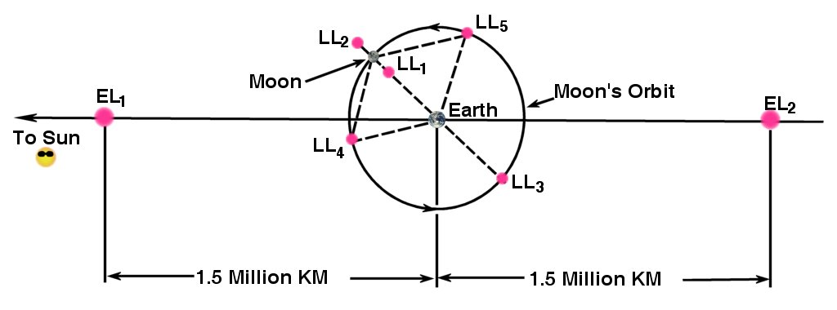
2. The InterPlanetary Superhighway
Figure 2. Schematic diagram of the Lagrange Points of the Earth-Moon (LL₁, …), and Sun-Earth Systems (EL₁, …).
Our Solar System is interconnected by a vast system of winding tunnels and conduits in space around the Sun and planets which we call the “Interplanetary Superhighway” or IPS for short (Lo, Ross [1], [2]). This ancient and giant labyrinth around the Sun is generated by the Lagrange Points of all of the planets and satellites within the Solar System. For every Three Body System (such as the Sun-Planet-Spacecraft system), there are five Lagrange Points (also known as libration points). These points are special locations in space where the gravitational forces and the rotational forces within the Three Body System are balanced. They were discovered by Euler (L₁, L₂, L₃) and Lagrange (L₄, L₅). Figure 2 shows schematically the Lagrange points of the Earth-Moon System and their geometric relationship with the Sun-Earth’s L₁ and L₂. For clarity, we will refer to the lunar Lagrange Points as LL₁, etc., and the Earth Lagrange Points as EL₁, etc. We refer to the region of space around the Earth containing all of these Lagrange Points as the “Earth’s Neighborhood”. It is a sphere of roughly 1.5 million km (1 million miles) radius around the Earth. Figure 1 provides an artist conception of a portion of the IPS in the Earth’s Neighborhood connecting the Lunar LL₁ Gateway with spacecraft in orbit about Earth’s EL₂ described in Section 4. Figure 3 shows an actual computation of a portion of the IPS which provides low energy transfers from low Earth orbit to a halo orbit at EL₂ for the TPF mission [3]. For an exposition on the dynamics of the Lagrange points and the foundations of IPS, see Koon, Lo, Marsden, and Ross, [4] and references therein.

The Geometric Structure of the IPS

Where does the tunnel in Figure 3 come from? The surface of the tunnel is generated by all the trajectories that asymptotically wind onto the halo orbit without any maneuver. This tube-like surface is called the stable manifold in Dynamical Systems Theory, a branch of mathematics studying the global behavior of differential equations. Dynamical Systems Theory is more popularly known as “Chaos Theory” from the discovery of “deterministic chaos” in the solutions of ordinary differential equations. Similarly, there is a set of trajectories which asymptotically wind off of the halo orbit without any maneuvers. This tunnel is called the unstable manifold. Figure 4.a shows an iconic diagram of the Earth’s global IPS at a particular energy level, E. Figure 4.b shows the typical tunnel structures generated by a periodic orbit around L₁, L₂, or L₃. Compare with Figures 1 and 3 to see the 3-dimension-ality of the tunnels.

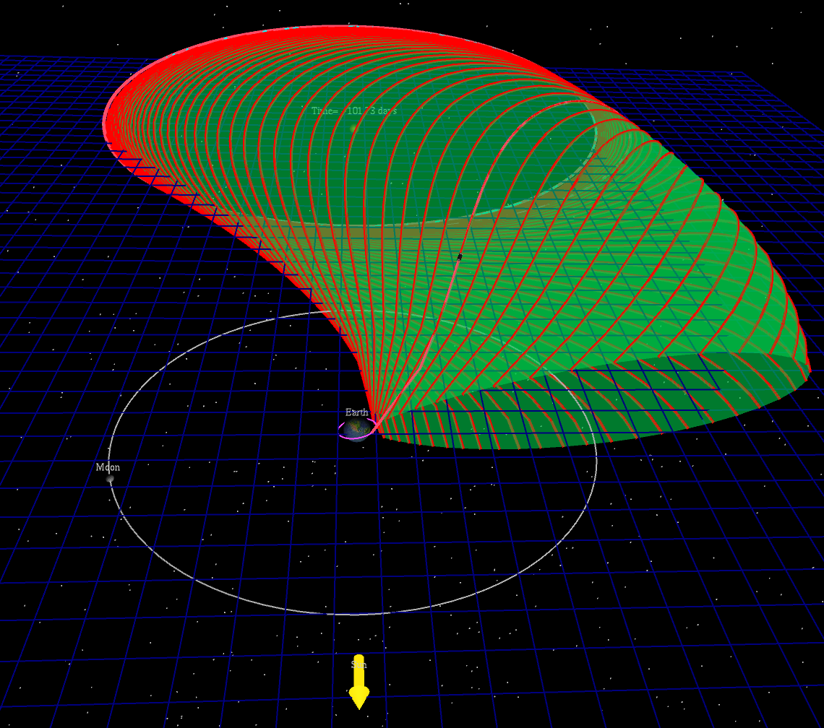

To Sun
Lunar Orbit

Earth Parking Orbit
IPS Tunnel Providing Low Energy Transfer from Earth Parking Orbit to EL₂ Halo Orbit

EL₂ Halo Orbit

Figure 3. The InterPlanetary Superhighway tunnel which provides a low energy transfer from Earth to a halo orbit at EL₂ (at the end of the tunnel) for the TPF mission [3].

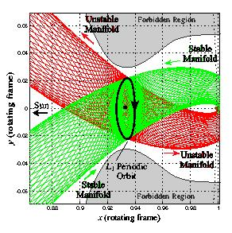
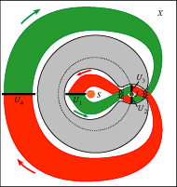
The periodic orbits (there are other types besides halo orbits) which generate the tunnels are truly the “portals” to this system of tunnels. To see this, let us select a tunnel system at the energy level E as in Figure 4 and examine transport within this system. Let us assume the planet here is the Earth. Note the three marked regions: S, J, X. S is the Sun Region inside the orbit of Earth. J is the Earth Region between L₁ and L₂. X is the Exterior Region, outside the orbit of Earth. Recall the gray horseshoe region is the Forbidden Region unreachable by particles with energy E. In order for a particle at energy E to enter or exit the J Region, it must pass through the periodic orbit at L₁ or L₂. For the planar case, where we assume all particles move only in the XY-plane (the Ecliptic here), there is a theorem guaranteeing this rule of transport (see Conely [5] and McGehee [6]). In the 3 dimensional case, recent results show a much more complex picture, but essentially the same as in the 2 dimensional case (see Gomez, Koon, Lo, Marsden, Masdemont, Ross [7]). Thus, in a very real sense, the periodic orbits act like portals to the J Region controlling all who pass through this region. At the same time, the neighborhood surrounding the periodic orbits are the “Freeway Interchanges” of the Interplanetary Superhighway. Because, it is here that one can select which of the four tunnels connected to the periodic orbit for travel (see Figure 4.b). Koon, Lo, Marsden, Ross [4] show that the system of tunnels generated by the periodic orbits is chaotic. In other words, the tunnels generate determinisitic chaos. This means that for very little energy, one can radically change trajectories that are initially close by. In Figure 5, we show a small portion of the surface of the tube of trajectories leaving the Genesis (see Lo et al, [8]) halo orbit which generates an Earth-Return trajectory. The effects of the lunar encounter are evident. One can imagine from this plot that the tunnel becomes highly distorted and torn apart as it winds around the Earth’s Neighborhood. Part of it escapes the Earth’s Neighborhood via the L₂ portal which is invisible here. Part of it is captured by the Earth-Moon system. If one looked carefully, one can even see the trajectory with a lunar encounter. Finally, some of it will eventually escape to the S Region via the L₁ halo orbit. Note these escape trajectories are the heliocentric orbits of SIRTF, SIMS, and StarLight.
4.a 4.b
Figure 4.a. An iconic diagram of the Earth’s global InterPlanetary Superhighway at a particular energy level, E. The green tunnels wind onto the periodic orbit at L₁ or L₂. The red tunnels go away from the periodic orbit at L₁ or L₂. These tunnels are 2-dimensional tubes in the 3-dimensinal energy surface projected onto the Ecliptic (Earth’s orbital plane). The gray region in a horseshoe shape is inaccessible to particles in the Sun-Earth system at the energy level E.
4.b. The typical detailed tunnel structures generated by a periodic orbit around L₁. The periodic orbit can be a Lyapunov orbit, a halo orbit, or other unstable periodic orbits around the Lagrange points.

Earth
3. IPS Trajectories Enables Origins Missions
Perhaps the most significant contribution of IPS to the Origins Program is the mission-enabling trajectories it provides. All of the libration orbits, heliocentric orbits (C₃ near 0), and formation flight around these orbits are part of the IPS family of trajectories.

Free Earth Sample Return Trajectory

Figure 6 shows the Genesis solar wind sample return trajectory which requires NO DETERMINISTIC ΔV (maneuver) after launch. Assuming a perfect launch with perfect navigation, the spacecraft will automatically insert into a halo orbit about L₁, collect solar wind samples for 5 revolutions (2.5 years) and automatically return to Earth, landing in Utah before noon. All of the maneuvers for the mission are for correcting statistical errors and for biasing the trajectory to compensate for spacecraft hardware limitations, plus margin. This design was achieved, as mentioned in the previous section, by exploiting the IPS structure depicted in Figure 5. We note here that the MAP Mission also used the IPS in its design of the lunar swingby to successfully achieve the tight lissajous orbit around L₂.
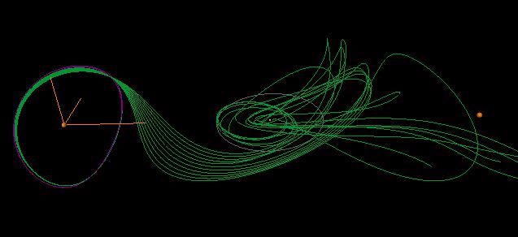

← To Sun

Earth

EL₁

EL₂

← Genesis

Halo Orbit

← Genesis

Return Orbit
Figure 5. Portions of the surface of the unstable manifold (green trajectories) of the Genesis halo orbit. This is part of the InterPlanetary Superhighway in the Earth’s Neighborhood which leads away from the Genesis halo orbit for a return orbit to Earth as noted in the diagram.
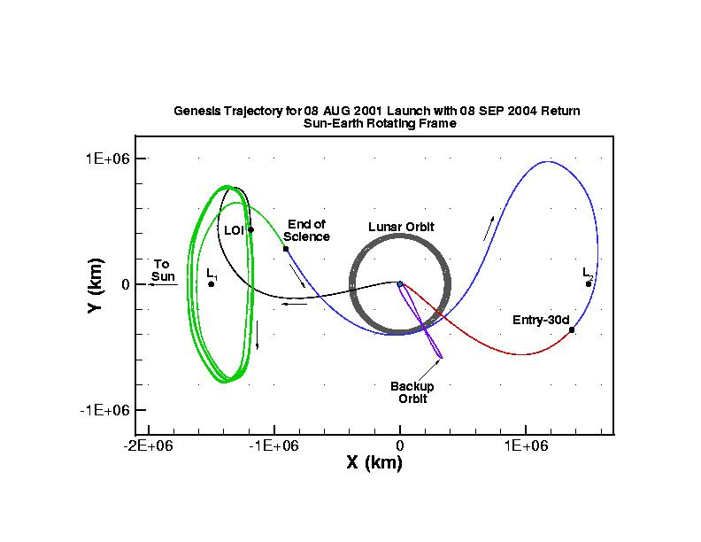
Lunar Orbit
↓

Figure 6. The Genesis orbit. Genesis will remain in an L₁ halo orbit for about 5 orbits (2.5 years) to collect solar wind samples and return them to Earth. The excursion to L₂ is needed to achieve a day-side (before noon) entry at the Utah Test and Training Range to facilitate the final parachute deployment with mid-air retrieval by a helicopter.

Formation Flight

The heliocentric orbits of SIRTF, SIMS, and StarLight are part of the IPS which escapes the Earth. The iconic diagram in Figure 4.a shows the IPS tubes which guide these trajectories. But, the more interesting case is that of the TPF formation flight about an L₂ halo orbit. Figure 7.a shows the initial formation of the 5 spacecraft and the 100 meter diameter 20-sided polygon (length of a football field) interferometer footprint. Figure 7.b shows the formation spiraling about the halo orbit (diagonal cyan curve) to achieve the desired footprint. Our knowledge of the IPS enabled us to demonstrate the feasibility of formation flight about a halo orbit at EL₂. Moreover, the deterministic maneuver cost for maintaining the formation whether around a halo orbit or around a heliocentric orbit is nearly identical. This assumes, of course, the trajectory design properly included the dynamics of the different regimes of the IPS.
← Lunar Encounter
Producing Capture Orbits
↑
Escape To Heliocentric Orbits Such As For SIRTF, SIMS, StarLight

Although the dynamics of halo orbits and heliocentric orbits are very different at first glance, our knowledge of the IPS enabled us to recognize that they arise from the same family of orbits but are merely in different dynamical regimes. The heliocentric orbit eventually will return to Earth. When it does, with a slight perturbation it can be brought back into the Earth’s Neighborhood where it will exhibit the chaotic dynamics of typical libration orbits such as halo orbits. This is important to the Origins Program since it is apparent that orbits in the Earth’s Neighborhood and those under the control of the IPS provide some of the best locations for observatory missions. Hence any new knowledge of the capabilities provided by the IPS will further enlarge the design trade space for Origins’ architects and designers.

Enabling Trajectory Planning Automation

This systematic approach not only provides ultra-low energy, mission-enabling trajectories, but will also enable automation. Computers can automatically generate the IPS segments desired and search them to find the cheapest transfers. Once automation is achieved on the ground, with more powerful computers and software, the process may be transferred to on-board spacecraft for autonomous trajectory planning and navigation in the near future. Without the IPS technology, it is difficult to see how autonomous trajectory planning may be achieved in these delicate and highly nonlinear dynamical regimes of space.
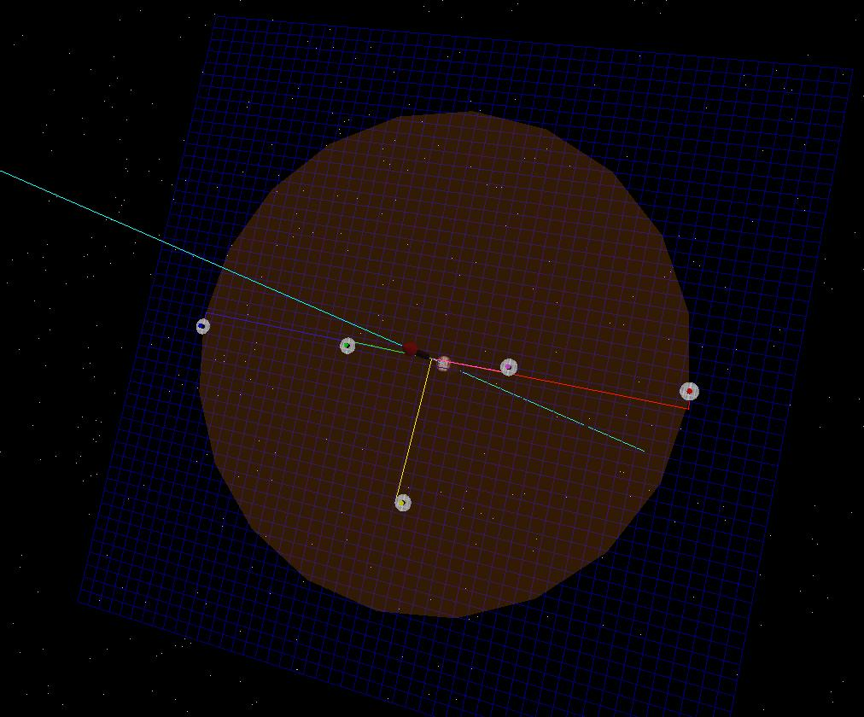
7.a 7.b
Figure 7. TPF formation flight around a halo orbit (diagonal cyan curve). The red vector at the center of the 20-sided polygon is the direction of the star which is being imaged. (a) The TPF formation at an initial configuration with 4 spacecraft along the 100 meter diameter of the 20-sided polygon (length of a football field). The collector spacecraft is off-set from the diameter as shown. Initially, this shows TPF pointing at a star along the direction of the halo orbit. (b) The TPF formation spiraling around the halo orbit and repoints to another star. The straight segments are the paths for repointing TPF at another star. The orange colored footprint is now pointed at another star.

← HALO ORBIT
← 100 METER
FOOT PRINT
4. IPS Enables Human Servicing of Origins Missions
In the last few years, the NASA Exploration Team is seriously considering providing human service to libration missions (Condon [9]). The problem is that, the 3200 m/s transfer to orbits around the Lagrange points from a 200 km parking orbit around the Earth requires approximately 3 months of travel time. With transfer orbits to EL₂ well outside of the Earth’s magnetic field, such a voyage would in principle be not very different from one going to Mars. To reduce the transfer time in any significant manner (down to one day) requires an increase of the transfer ΔV by roughly an order of magnitude. The infrastructure cost and risk for both options are extremely high. At the 2000 Lagrange Points and the Exploration of Space Workshop in Pasadena, CA. [10] (see also [2]), Lo suggested an alternate approach using the Lunar LL₁ as a base of operations for servicing missions like TPF at the Earth’s Lagrange points.

By placing a Lunar Gateway Habitat (see Figure 8) in orbit around LL₁, the spacecraft at EL₂ can be brought back and forth to LL₁ with relatively little cost. The point design trajectory presented in [2] requires only a single 14 m/s deterministic maneuver (statistical maneuvers not included) to convey a spacecraft from LL₁ to EL₂ orbit (see Figure 9). Transfers from EL₂ to LL₁ would have similar costs. With optimization, even this small deterministic maneuver may be removed in most instances. The transfer from the LL₁ to EL₂ region requires about 38 days. This efficient transfer is achieved by the dynamical channels in the “InterPlanetary Superhighway” generated by the Sun-Earth-Moon system. For rendezvous missions, the transfer time will be of the order of months which may be shortened by additional maneuvers.
← REPOINTING
PATH
← HALO ORBIT

Lunar L₁ is an ideal and logical next step for extended human presence in space beyond LEO (Low Earth Orbit). To first order, from energy considerations, it requires only a ΔV of 3150 m/s to reach LL₁ from a 200 km parking orbit around Earth. Although, this will vary depending on the transfer time and the final orbit desired. In the worst case, it is bounded above by transfers to the Moon which we know how to do. We are currently studying this mission scenario. Station keeping is required once or twice a week with a total

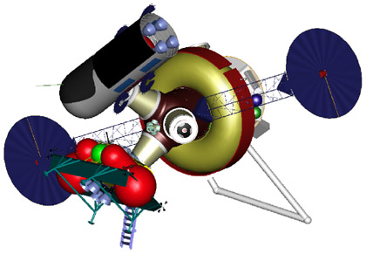
Figure 8. The current design of the Lunar L₁ Gateway Habitat by the Johnson Space Center’s Exploration Office.
ΔV budget around 10 m/s per year (Gomez et al [11]). However, advances in navigation technology in the next decade may provide a completely autonomous system for station keeping with even lower cost. Communications is relatively simple, since LL₁ is close by and always in view of the Earth. And, of course, NASA has a tremendous amount of experience with human missions to the Moon. This fact alone greatly reduces the risk of this approach.
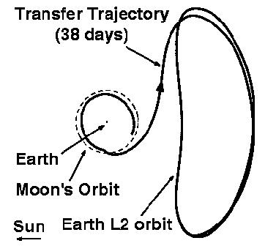
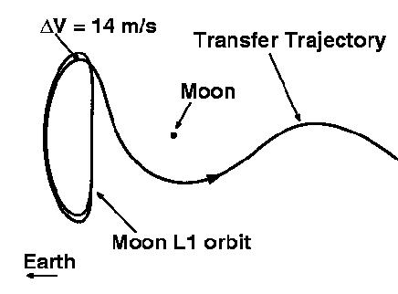
.
LL₁
.
LL₂
.
EL2
9.a In Lunar Rotating Frame 9.b In Earth Rotating Frame
Figure 9. Transfers between planar periodic orbits around Lunar L₁ and Earth L₂. (a) The periodic orbit around the Lunar LL₁ needs a 14 m/s maneuver to get onto the transfer orbit. (b) The transfer orbit going from the Moon to the Earth’s EL₂ periodic orbit. Note the lunar periodic orbit appears as an elliptical orbit here in the Earth rotating frame.

These facts combine to suggest that a halo orbit around LL₁ provides an ideal location for a “service station” or a “hub” for missions in Earth libration orbits. Moreover, as shown in Paffenroth, Doedel, and Dichmann [12], there are large families of orbits with similar characteristics to halo orbits in the Earth’s Neighborhood (the region between EL₁ and EL₂) which will be useful for future missions. Spacecraft in these orbits may also be serviced by the LL₁ Gateway. Beyond the Earth’s Neighborhood, LL₁ can also serve as a point of departure for missions with destinations ranging from Mercury to the Kuiper Belt and beyond (the low thrust trajectory to Mars in Section 8 goes by LL₁ and LL₂). By taking advantage of the dynamics of the IPS of the Sun-Earth-Moon system, launches from the LL₁ Gateway can effectively increase the narrow launch periods of interplanetary missions from a few days to weeks and months. This is achieved by launching earlier and spending the extra time in the Earth’s Neighborhood until a final Earth flyby with injection onto the desired interplanetary transfer orbit. During the time in the Earth’s Neighborhood, additional lunar and Earth flybys can further increase the energy of the spacecraft. Halo orbits near LL₁ or ₂ are truly the portals to the Solar System and beyond.

5. IPS Model of the New Solar System
In this section, we examine a new model of the Solar System suggested by the IPS. IPS models the Solar System as a series of coupled three body problems. This differs from the Copernican model which views the Solar System as a series of two body problems in Keplerian conic orbits. This shift in the model introduces a completely different para-digm for the Solar System. The two key ideas are:

- IPS provides a new paradigm through which we can better understand the dynamical behavior of the Solar System.
- Understanding the IPS and mimicking the behavior of natural bodies such as comets, asteroids, and zodiacal dust under the influence of IPS can provide valuable insight and new techniques for designing innovative low-energy missions with hybrid propulsion systems (continuous & impulsive).

Copernican Solar System

In the Copernican model, the Solar System is a series of planets moving in nearly circular orbits isolated from one another. Asteroids and Kuiper Belt Objects (KBO) similarly are moving in nearly circular orbits. Perturbations from Jupiter and the other planets or passing sars can cause the orbits of asteroids or KBO’s to become more elliptical and through a series of complex dynamics, they may be moved into the Inner Solar System, or they may escape the Solar System. Comets present a challenge as their orbits appear to be very erratic. Their orbital parameters can change at will, caused by the perturbations, especially due to close approaches to Jupiter and Saturn. The main approach is to start from conic orbits and add perturbation terms to explain “non-conic” behavior. This is an over simplification of a complex and sophisticated theory, but is a rough sketch of the key ideas. Its conic-centric view is a legacy of the pre-computer age. Without the computer, it is hopeless to compute anything very far from a conic orbit. Consequently, highly nonlinear behavior and chaotic dynamics are very difficult to analyze in this paradigm.
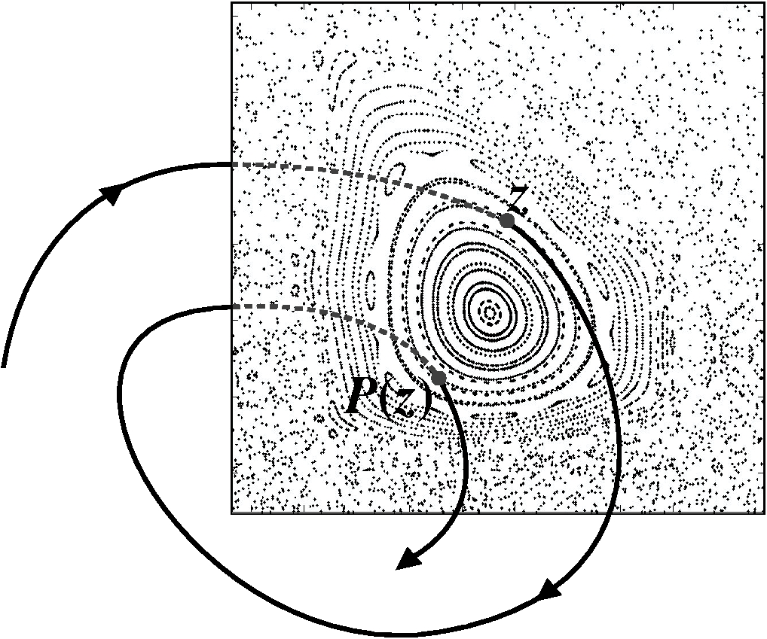
Figure 10. The Poincaré Map is produced by placing a plane normal to the path of the orbits and collect the points of intersection each time the orbit crosses the plane. The resulting discrete map of discrete points may be used to analyze the dynamics to great effect. Here, the point “z” is mapped to P(z) by following the trajectory’s next intersection of the plane. The closed circles represent quasiperiodic orbits on tori within the islands of stable orbits. The sea of dots are the chaotic orbits. Such patterns are difficult if not impossible to detect by observing the orbits themselves.

The IPS Solar System

The computer age gave nonlinear dynamics a new birth. The invariant manifolds of the IPS which were theoretical curiosities before, all of a sudden now can be computed and analyzed with the computer. The Three Body Problem which gave Newton headaches can now form the basis of a new model of the Solar System. The IPS models the Solar System as a series of Three Body Problems which are coupled. Frequently, a simpler model is used where the coupling is removed. In this case, the orbits and manifolds of the Three Body Problems may be used intact to provide insight and initial guess solutions to be refined by the addition of the coupling forces via numerical integration. This semi-analytical or semi-numerical approach is highly successful both for theoretical investigations as well as for practical engineering applications.

Before we present the IPS model of the Solar System, we need a technical device called a Poincaré map. When working with nonlinear trajectories, the examination of a trajectory plot after thousands of revolutions is unrevealing. One sees nothing but a jumbled mess of spiralgraph curves. However, if instead, we place a plane normal to the orbital paths and simply collect the points of intersection every time the orbit crosses this plane, we obtain a map named after its inventor, Poincaré. This is illustrated by Figure 10 above. By changing the coordinates of the points to dynamically meaningful quantities such as semimajor axis or eccentricity, an amazing picture is revealed out of this apparent sea of chaos.

Figure 11 is a visual summary of the IPS model of the Solar System from numerical simulation. The caption under the figure explains in greater detail how the data is generated and how to interpret this figure. It shows that the Solar System is not merely a collection of isolated planets and satellites in nearly circular orbits about the Sun. Instead, it is an organically connected entity with a dynamic and complex structure. Every part of the Solar System is able to communicate with every other part via the InterPlanetary Superhighway visually displayed here in the Poincaré section.

IPS and the Asteroid Belt

We focus now on Jupiter’s L₁ invariant manifolds. This is the left most curve of solid green dots in the figure separating the comets from the asteroids. This curve has a highly negative slope. What it says is that the orbits in the L₁ branch of Jupiter’s IPS tends to become more and more eccentric as its semimajor axis becomes smaller and smaller. Note how hopeless it would be to try to understand this phenomenon using a conic model. While every point here has the exact same three-body-energy (Jacobi constant), its two-body-energy, which depends on the semimajor axis, is changing radically and appears to be losing energy erratically. Before leaving this figure, we make an important final observation that at the right end of the Jupiter L₁ manifold, its semimajor axis is about 4 AU and its eccentricity is less than 0.05. These orbits are fairly circular. But at the left end of the Jupiter L₁ manifold, its semimajor axis is about 2 AU and its eccentricity is about 0.7. Clearly, these orbits must now cross the orbit of Mars.

We now replot the Poincaré section of the Jupiter L₁ manifold by itself in Figure 11 using the longitude of perihelion in the rotating frame as the Y variable. Note the dramatic change in appearance. This Swiss cheese plot is typical of chaotic motion. Recall that this map is generated by the invariant manifold of Jupiter’s L₁ point which is just two curves, since the stable manifold and the unstable manifold of the L₁ point are degenerate tubes, or single curves. What this plot says is that these two trajectories are moving all over the place from a semimajor axis of nearly 5 AU to 2 AU. Such behavior is typical of chaotic motion. The holes in the plot are the resonances. Stable resonant orbits typically spiral around a central stable perioidic resonant orbit. Hence, they live on tori (pleural of torus) of high dimension. When a torus intersects the plane, the resulting section is a circle, hence the holes in this map.

By comparing the resonances of Figure 12 with the eccen-tricity plot of Figure 11, we show that the 3:2 Hilda Re-sonance tends to collect asteroids because its nearly circular orbits do not cross the path of Jupiter. Where as at the 2:1
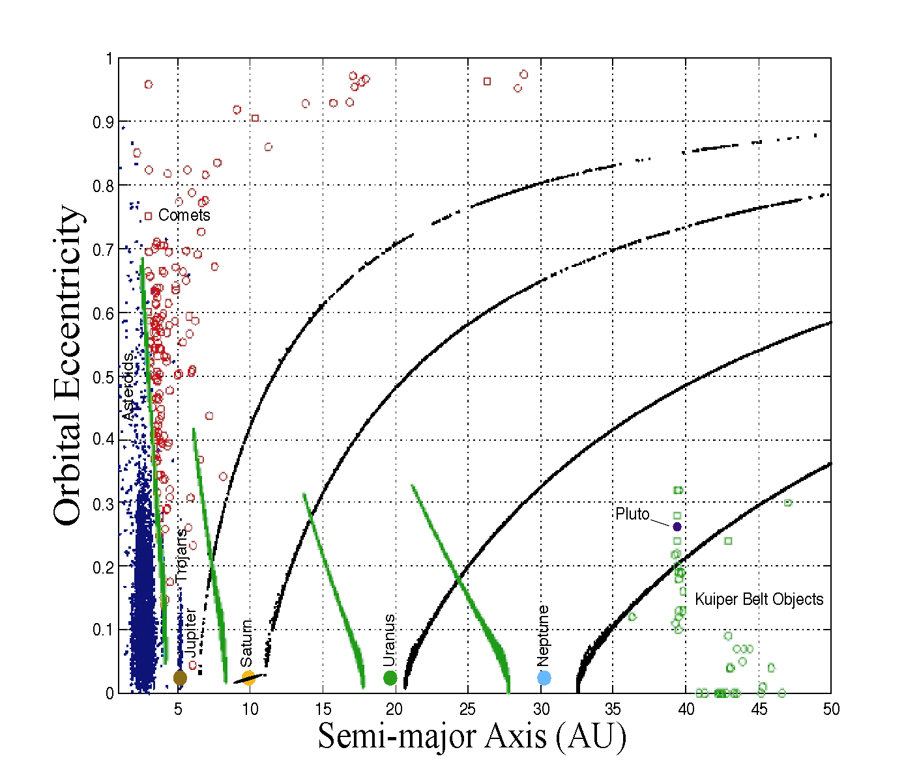
Kirkwood Gap, the orbital eccentricity is so high, these orbits cross the path of Mars and are thus eliminated to create the famous Kirkwood Gap at the 2:1 resonance.

Kuiper Belt Objects
KBO
Comets
Asteroids
Figure 11. This is a Poincaré section of the IPS in the Outer Solar System. The IPS of the Inner Solar System is too small to be viewed at this scale. Each point is taken from an orbit intersecting this plane for thousands of integration periods. The X-axis is the Semimajor axis of the point, the Y-axis is the orbital eccentricity of the point. The curve (solid green dots) to the left of the planet is the invariant manifold (IPS) of the planet’s L₁. In particular, this branch grows out of the planet’s L₁ point with the energy (Jacobi constant) of L₁. The curve (black dots) to the right of the planet is the invariant manifold (IPS) of the planet’s L₂. Note the L₂ IPS of Jupiter intersects the L₁ IPS of Saturn, providing a low-energy transport between the two planets. Similarly, between all of the Outer Planets, such a transport mechanism is available. Hence the Kuiper Belt Objects (open green circles) are able to move along the IPS right into the heart of the Asteroid Belt (solid blue dots) on the far left of the figure. The comets (open red circles) are clustered above Jupiter’s L₁ manifolds. While the asteroids are below them. IPS is, in fact, the separatrix for each of the planets, separating the stable motion (below) from the unstable motion (above).

We note again that this Poincaré section is computed with just a single trajectory, Jupiter’s L₁ unstable manifold. The stable manifold is obtained by symmetry. From these two trajectories, we are able to glean a tremendous amounts of information about the structure of the Asteroid Belt. The inclusion of the manifolds of the other planets provide our first view of the IPS connecting the entire Solar System in a dynamic fashion. Figure 1 depicts how these manifolds interact with one another. In a very real sense, the Lagrange Points are the seeds of the Solar System’s dynamics. Their manifolds, the spiraling two stands of orbits are like the DNA of this dynamics. The dynamical astronomy community would describe these orbits as “genetic” precisely because they characterize the general behavior of the orbital dynamics in this regime.

By analogy (and limited simulations), the behavior of Kuiper Belt Objects and certain aspects of planetary ring dynamics are also influenced by the IPS. In fact, using the IPS of the Jovian satellites, we have implemented a mission concept called the “Petit Grand Tour” to successively orbit the moons of Jupiter, using the IPS to transfer from moon to moon, and using the IPS to “temporarily capture” into orbit about the joving moons (see Koon, Lo, Marsden, Ross [13]).
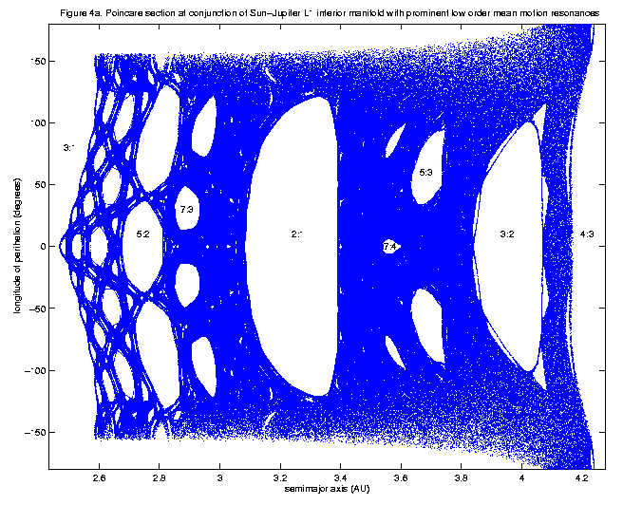
The IPS and Comets
2:1
Kirkwood Gap
3:1
3:2
Hilda Group
Figure 12. Poincaré Section of Jupiter’s L₁ manifolds plotted in SEMIMAJOR AXIS vs. LONGITUDE OF PERIHELION reveals the resonance structures of the dynamics between Jupiter and Mars. The 3:2 Hilda Resonance at the far right has low eccentricity (see Figure 10) hence do not cross the path of Jupiter. Asteroids tend to collect and remain there producing the Hilda Group of asteroids. At the middle, the 2:1 resonance is one of the famous Kirkwood Gaps. Here, the eccentricity of the orbit is so high (see Figure 10), they cross the path of Mars. Hence Mars encounters knock them out of this resonance thereby creating a gap. All of the resonances to the left of the 2:1 gap have this property.

The IPS explains three interesting behavior of comets:

- Temporary Capture
- Resonance Transitions
- Planetary Impact

In Figure 13.a, we exhibit a system of pathways linking the S, J, X regions of Jupiter with two periodic orbits around Jupiter’s L₁ and L₂. This chain of orbits is called a homoclinic-heteroclinic chain and is an important cycle within the Jovian IPS. In Figure 13.b we have superimposed comet Oterma’s path over the chain. Note the remarkable resemblance between the comet’s path and the chain. This suggests that comets closely shadow such paths within the IPS. Howell, Marchand and Lo [14] examined the motions of Helin-Roman-Crockett by matching the pieces of Jupiter’s IPS tunnels with the comet orbit shadowing them. This confirms the initial observations of Lo and Ross [1] that the temporary capture phenomenon of Jupiter comets is controlled by Jupiter’s IPS generated by its Lagrange points. In fact, the Shoemaker-Levy 9 comet followed precisely the Jovian IPS to its spectacular final demise crashing into Jupiter. Chodas [15] noted its passage close to Jupiter’s L₂. This is further confirmed by our simulations. Similarly, the Genesis Trajectory is really an Earth impact trajectory that Near Earth Asteroids and Comets can follow, leading to similar impacts. It is estimated about 1% of the Near Earth Objects fall into this category and are considered the most dangerous because they have orbits that naturally lead to Earth impact (Valsecchi, [16]) like the Genesis orbit. Michael Mueller (author of the Nemesis Star Theory) and Walter Alvarez [17] noted there is evidence that the asteroid which impacted the Earth and wiped out the dinosaurs may have followed a Genesis-like orbit.
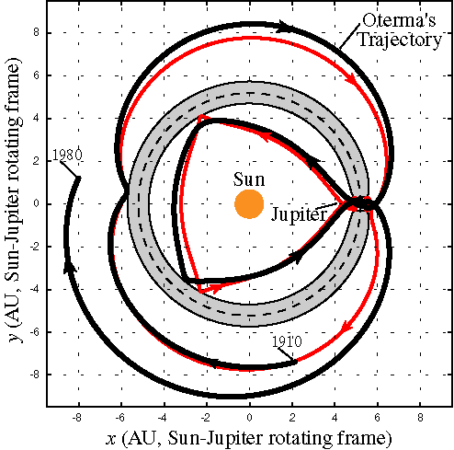
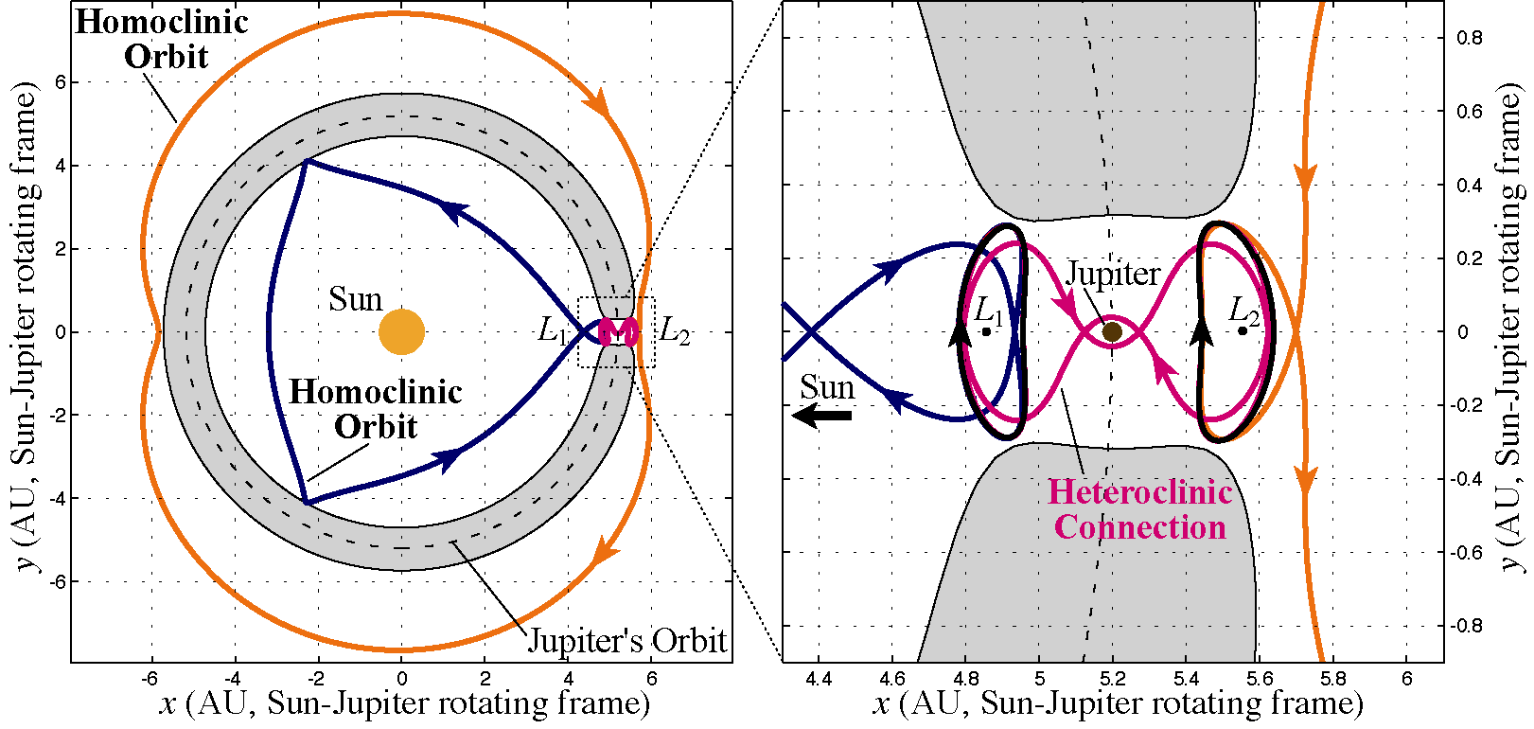
But instead of doomsday, through a series of well chosen maneuvers one may be able to capture such a rogue asteroid or comet in the Earth-Moon system and tame it for an almost infinite supply of precious resources! In Koon, Lo, Marsden, and Ross [18], it is shown how ballistic lunar captures may be achieved using the IPS. This, of course, uses exactly the same dynamical mechanism for the temporary capture of Jupiter comets. In this dynamical regime, finesse is the key.
13.a 13.b
Figure 13.a. A homoclinic-heteroclinic chain within the Jovian system. These are a special set of trajectories linking the S, J, X regions of Jupiter via two of its periodic orbits at L₁ and L₂. 13.b. The orbit of comet Oterma superimposed on the chain showing how closely the comet orbit is guided by the chain.

Seeing such a complex array of chaotic behavior, one is tempted to despair. But just the opposite is true. This complex jumble can be analyzed and classified with the utmost precision using modern mathematical and compu-tational methods. Furthermore, the existence of deterministic chaos is the source of “Low Energy Transport” within the Solar System. It is precisely deterministic chaos which permitted the design of a completely ballistic trajectory for the Genesis Mission mentioned earlier. Also, Koon, Lo, Marsden, and Ross [4] provides one of the classifying theorems. It states that given any positive integers N_{S}, N₁, N_{J}, N₂, N_{X}, there exists a natural orbit which winds around the Sun for N_{S} revolutions in the S Region, winds around L₁ for N₁ revolutions, winds around the Earth for N_{J} revolutions, winds around L₂ for N₂ revolutions, and winds around the X Region for N_{X} revolutions. In fact, for an infinite sequence of such integers going between the S, J, X regions, such a natural orbit exists. Hence comets like Oterma, Gehrels3, Helin-Roman-Crockett, or Shoemaker-Levy9 are simply following the recipe given by this theorem.

The basic dynamics and mathematical theory explaining this behavior based on three body dynamics was worked out in Koon, Lo, Marsden, Ross [4]. An application using both the Temporary Capture and a transfer via the IPS to explain the recovery of the Hiten Mission first proposed by Miller and Belbruno [19] is given in Koon, Lo, Marsden, Ross [18].

We close this section by remarking that the InterPlanetary Superhighway plays an important role in the control of the motions of the Asteroid Belt, the Kuiper Belt, the planetary rings, the giant zodiacal dust tori. The transport within the Solar System and its effects on the morphology of structures within the Solar System are governed to a great extent by the IPS. The picture we should keep in mind as we leave this section is that the Solar System is dynamic and connected from the Kuiper Belt to the Sun by this invisible, complex system of tunnels and pathways, orbiting and intersecting one another like the gears within a giant clock. Instead of planets orbiting the Sun in isolated Keplerian orbits, the Solar System is an integrated entity, whole and organic, con-stantly evolving with material moving in and out via the IPS.

6. IPS Approach to Planet Detection
IPS also provides a pathway for dust particles from the Kuiper Belt to the Sun. Terrestrial planets create colossal rings many times the size of Jupiter via the IPS in the circumstellar dust disks of extra-solar systems which are observable from the ground. In Figure 14.a, we simulate the zodiacal dust ring around the Earth’s orbit using the IPS (gravity only). Clearly, such a large object with a 2AU diameter is observable with telescopes such as Keck which is able to resolve Jupiter-size planets.

We propose to determine the dynamical signatures of exo-terrestrial planets in the dust disks of extra-solar systems generated by their IPS. The signatures can be detected from precursor observations to infer the existence of terrestrial planets. The TPF Mission (Terrestrial Planet Finder) can use this method to select candidate stars for observation and validate its observations during operations.

We model the dust disk as particles moving under the force of the Poynting-Robertson (PR) drag in the restricted three body problem (Sun-planet-particle). Particles continually move from one energy surface to another (due to PR drag) in a Hamiltonian system where rich structures like periodic orbits, invariant manifolds, stable resonant islands, and resonant overlapping regions are all available for analysis. For particles of interest to planet detection, the PR drag is small and only perturbs but does not destroy the structures controlling the transport. Simulations of zodiacal dust and low-thrust trajectories validate this approach.
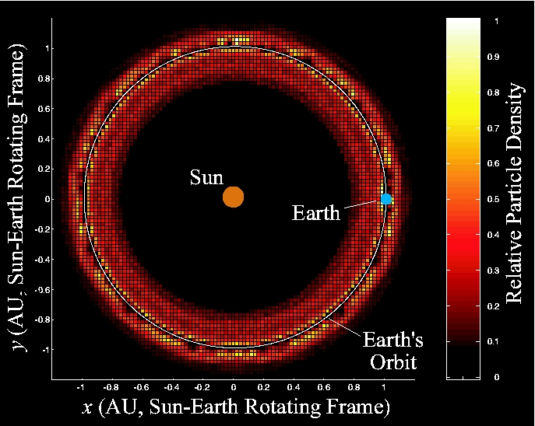
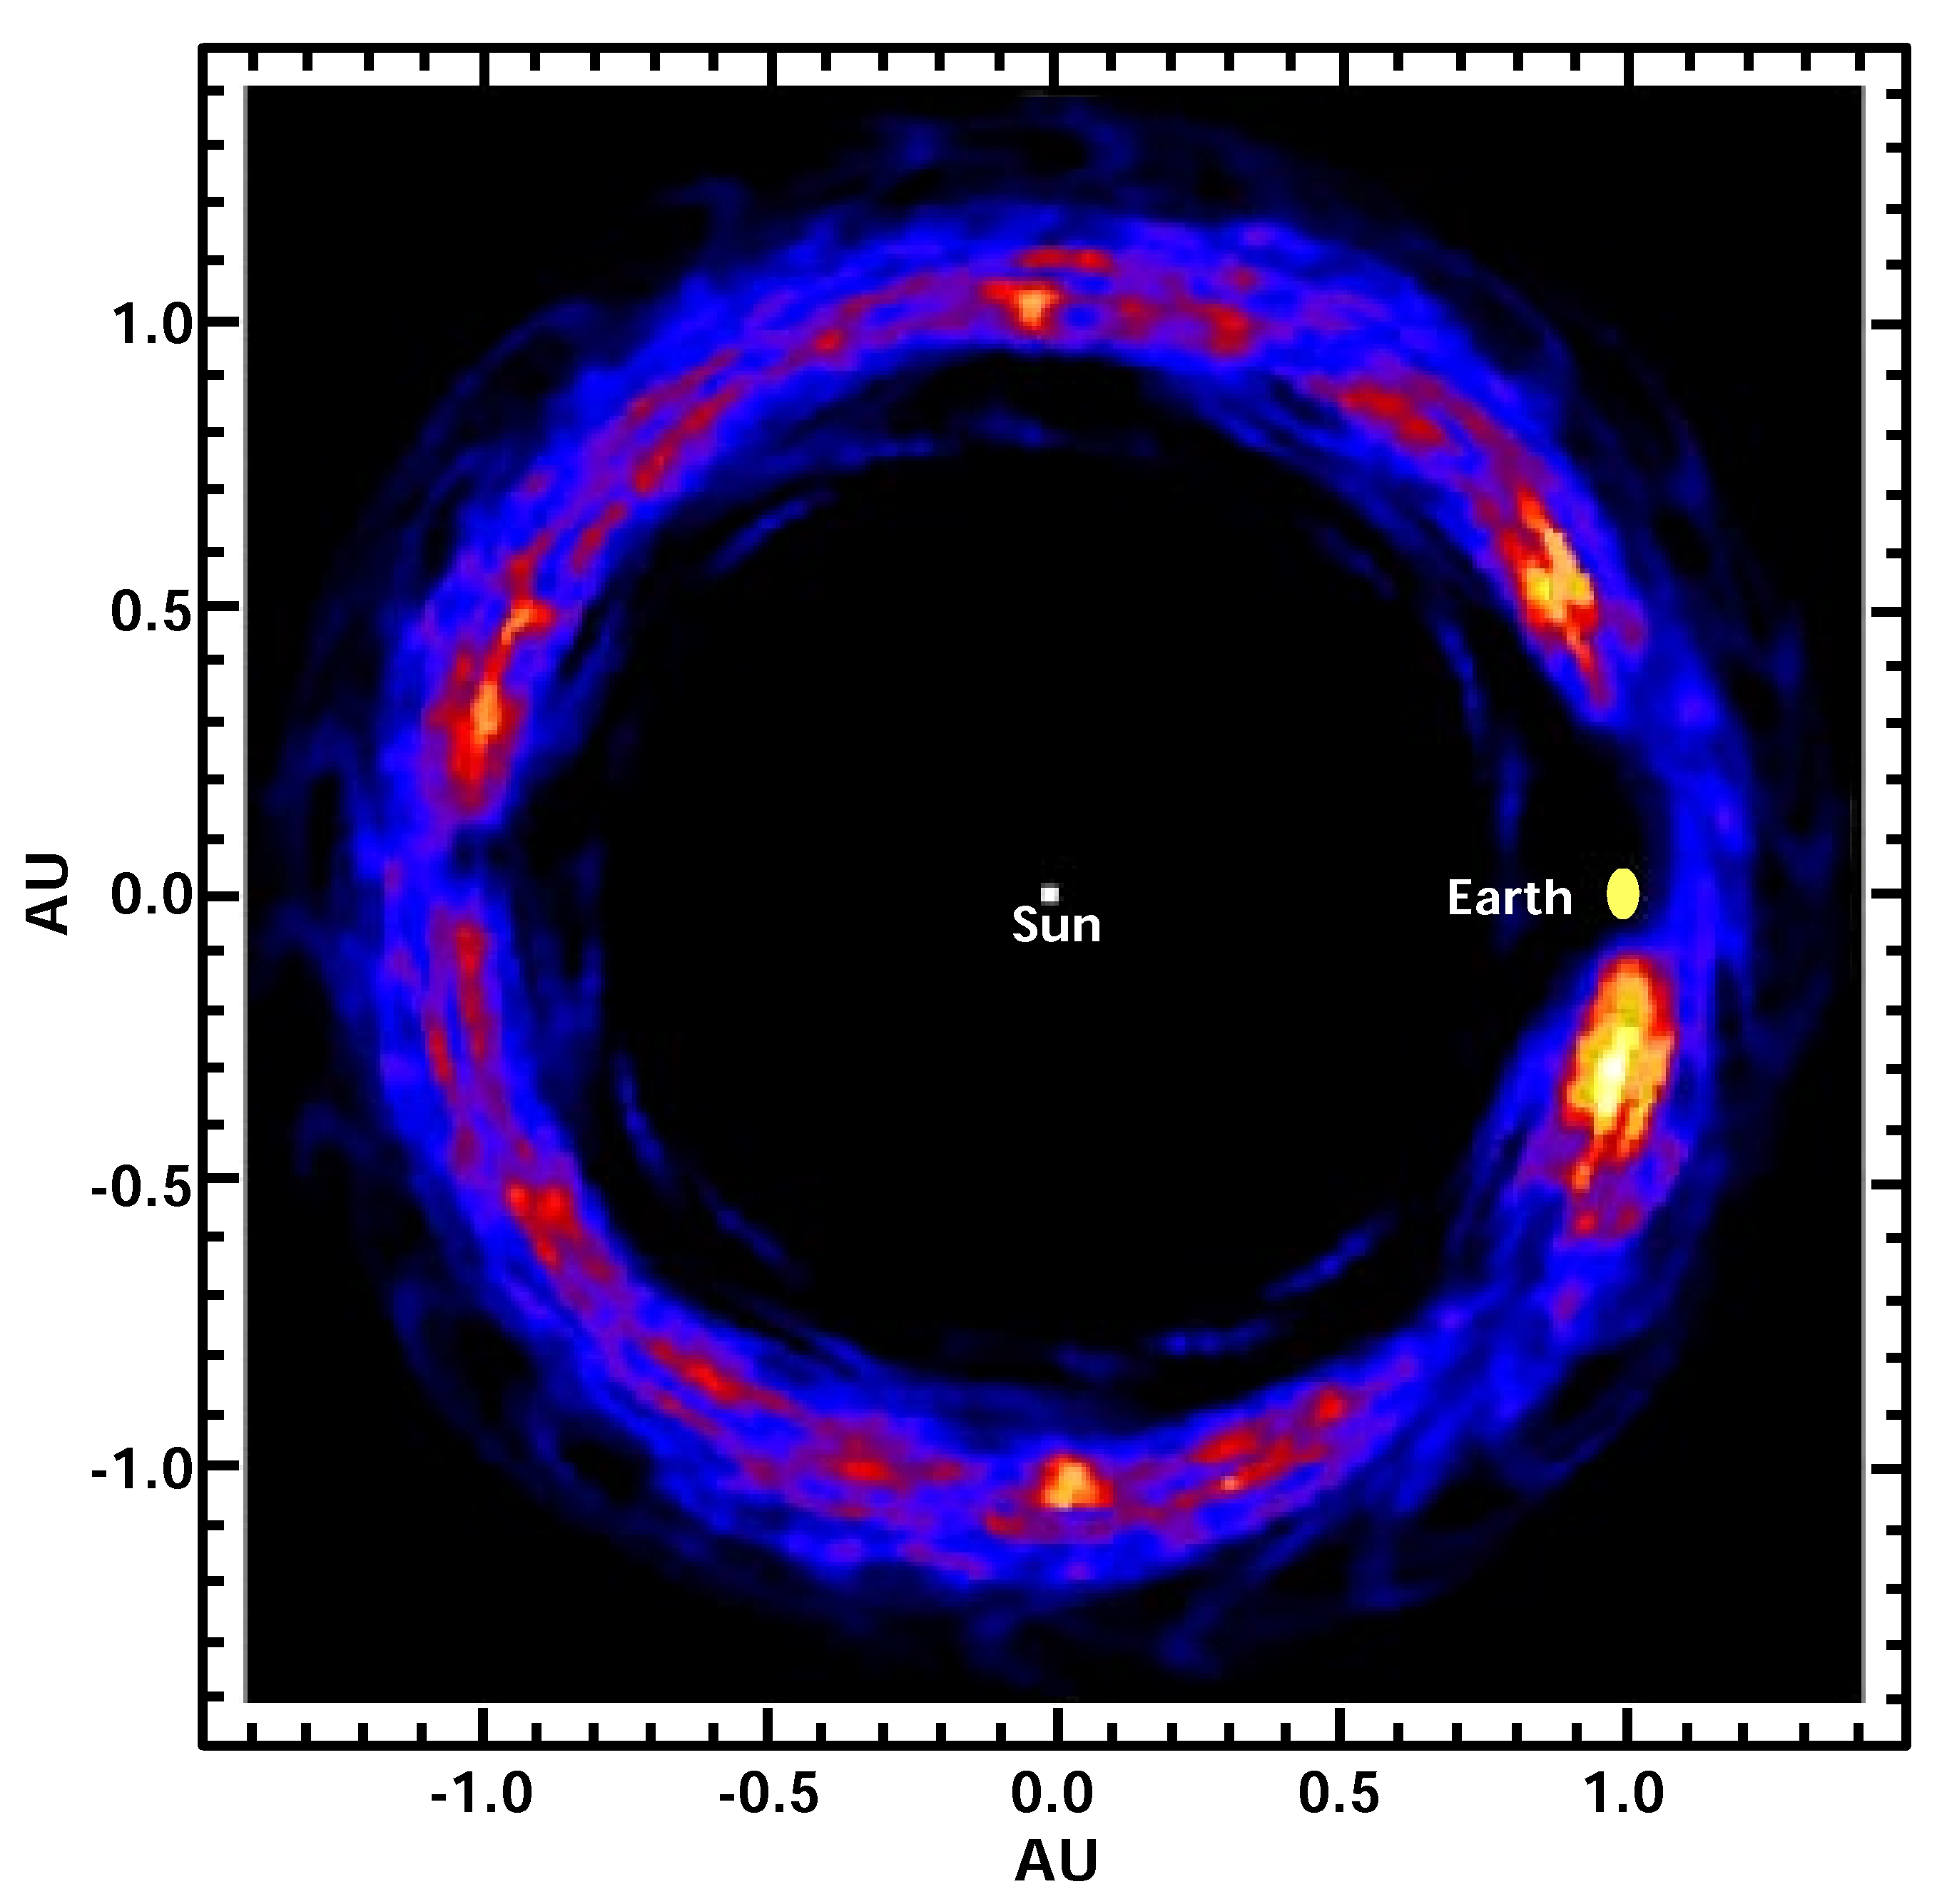
14.a 14.b
Figure 14 Our method for computing circumstellar dust signatures of planets is more efficient than previous methods and gives more interesting information. Compare our zeroth order model of Earth’s zodiacal dust cloud (a) with a previous model (b). By selecting the most relevant objects to compute, we can quickly and efficiently determine important morphological features (e.g., high density clumps). The numerical simulation in (a) used only one test particle on a specially chosen trajectory, compared to about 1000 trajectories in (b) (taken from Dermott, Jayaraman, Xu, Gustafson, and Liou [20]).

We can provide the signature of terrestrial planets from
- Simulations of transport through the IPS including close planetary flybys.
- Computation of global transport coefficients and transition probabilities by the methods of almost invariant sets (see Dellnitz and Junge [21]).
- Theoretical foundations of IPS dust transport.
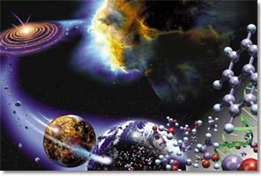
The theoretical and numerical work on extra-solar planet detection can be validated by working with precursor observers like the Keck Shared Risk Science Program. This will provide candidate stars for TPF observations and guide the work on the theory of dynamical signatures of planets in dust disks.

7. IPS: The River of Life
The fact that IPS controls the motions of asteroids, comets, and the zodiacal dust is a good hint that it plays a major role in the origin and development of life within the Solar System. On the one hand, the IPS brings the organic building blocks of life from the comets and asteroids to the Earth to support the development of life. Figure 15 below is an artist’s conception from the Origins Program’s web site showing a path for the development of life. IPS is a part of that path. On the other hand, the IPS brings asteroids and comets that impact the Earth, destroying hundreds of species and changing the course of the development of life on Earth again and again. The rise of mammals, leading eventually to humans could not have happened without the destruction of the dinosaurs by the asteroid at the KT Boundary.

The transport theory for the zodiacal dust proposed in Section 6 above can be used to estimate the rate of organic material transport to the Earth and contribute to the fundamental estimates in astrobiology to answer the question how life began on Earth. Perhaps, such a theory may also help us locate those extra-solar systems which may be better disposed to the development of life by the similarity of their material transport with our own Solar System.

Figure 15. IPS plays an integral part in the transport of life’s building blocks from various parts of the Solar System to the Earth.

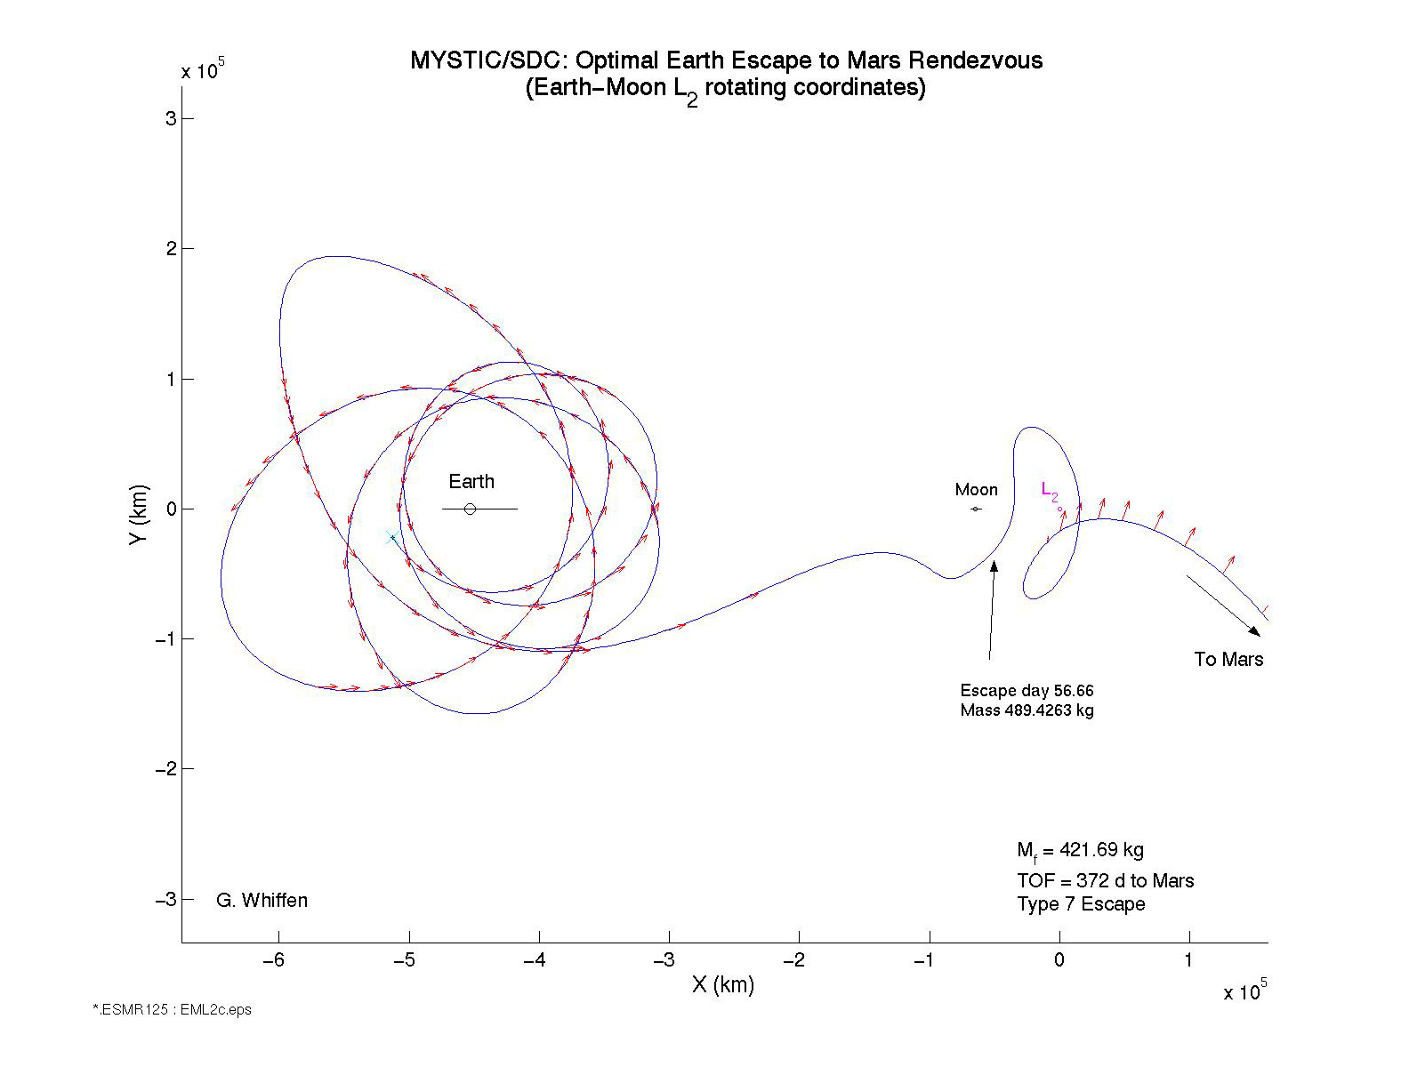
8. IPS and Science & Engineering
Figure 16. A low thrust trajectory to Mars which “accidentally” found its way into the IPS of the Earth-Moon system. The characteristic transfer from LL₁ to LL₂, and the halo-like loop around LL₂ show that this trajectory is indeed going through the tunnels of the IPS. This trajectory was computed using the MYSTIC/SDC low thrust trajectory optimization program by Gregory Whiffen at JPL.

IPS contributes to the Origins Program by its role in stimulating broader scientific and engineering developments which will benefit the Origins Program both directly and indirectly. We provide four examples, but we only develop the first one in some detail in this paper.

IPS and Low Thrust

First example, low thrust (and continuous thrust) trajectory optimization is intimately related to IPS theory. A hint is given by the fact that many comet orbits are controlled by the IPS. Figure 16 above is a low thrust trajectory designed to reach Mars. It “accidentally” found itself going through the lunar IPS tunnels from LL₁ to LL₂, and almost capturing into a halo orbit around LL₂ before final departure for Mars.
This, of course, is no accident. To understand how this works, we must go back to Figure 12, the Swiss cheese plot showing how the invariant manifolds wend their way through all of the resonances of the three body system. We must also recall our approach to simulating the zodiacal dust with PR drag in Section 6. Putting all this together we have the following picture. Low thrust trajectories typically start from some circular orbit around the Earth. As it gradually spirals out of the Earth’s gravity well, it’s slowly moving from energy surface to energy surface. Here we are working with the energy of the restricted three body problem, the Jacobi constant. At some point, it reaches an energy surface where there is chaotic motion much like the dynamics of Figure 12, the Swiss cheese diagram. The sensitivity of the chaos in this layer will move the trajectory great distances with little propulsion. However, the motion is not random. In Hamiltonian systems, for any given resonance there is always a pair of stable and unstable periodic resonant orbits. The unstable resonant periodic orbit acts just like halo orbits. It has stable and unstable manifold tubes winding on and off of itself just like the halo orbit. The intermingling of all these invariant manifolds is what creates the chaotic sea in Figure 12. The fact that we can use the Hamiltonian structure comes from the point of view we adopted to simulating the zodiacal dust. We imagine the thrusting spacecraft to be moving from energy surface to energy surface. But due to the small thrust (like the PR drag), this effect is sufficiently small so that for extensive periods of time, the energy surfaces are not changing too quickly and the behavior is amenable to this approach of analysis.

What this means is that in order to fully understand continuous thrust trajectories, we must understand the larger picture of the IPS, including all of the unstable periodic orbits and the tunnels and tubes that they produce which form an integral part of the IPS.

For the Origins Program, low thrust trajectories will provide additional degrees of freedom and flexibility in the design trade space and in related program architecture activities such as the human servicing of Origins missions.

Robust Computations of Trajectory Bundles

Second example, the computation of IPS trajectories requires the analysis of large families of trajectories which form high dimensional surfaces called manifolds. The departure from manipulating single trajectories to handling large bundles of trajectories requires development in computational mathematics and advanced software technology. The resulting advances will provide robust trajectory tools with guaranteed accuracy, using very large scale distributed computations, leading to the eventual automation of trajectory and navigation design. One of the key techniques here is “interval analysis” where instead of computing with individual numbers, we represent each number X as an interval (X-ε, X+ ε), where ε is the half interval. Interval arithmetic bounds the resulting computation to guarantee precision and accuracy. Barr and Graviliu [22] of the Caltech Graphics Group have recently discovered a new algorithm for interval arithmetic which is the square root of the previous complexity. Thus a computation requiring 10,000 calculations, now requires only 100 using this new algorithm. We are working together on applying interval methods to mission design and navigation.

Interval arithmetic can also be used to rigorously prove mathematical theorems. Wilczak and Zgliczynski [23], recently extend the heteroclinic orbit calculation in Koon, Lo, Marsden, Ross [4] and used interval analysis to provide a computer assisted proof of the existence of the heteroclinic orbit we computed. In the same way, when future trajectories are computed, their existence may be guaranteed by interval methods. Moreover, interval arithmetic can provide additional information on the robustness and sensitivity of the trajectory. This leads to robust algorithms for navigation and maneuver design which form a crucial step towards the automation of trajectory planning and navigation both on the ground and on-board the spacecraft.

From AU to au

Third example, the atomic physics of the chemical bond of a highly dissociated hydrogen atom under cross fields (magnetic and electric) is intimately related to the physics and mathematics of the IPS. Thus, from AU (astronomical units) to au (atomic units), IPS theory can be used to compute the transport of materials in the astronomical case and that of electrons in the atomic case. This connection was first brought to my attention by Jaffé [24] and Uzer [25]. We are currently working on a reinterpretation of results from atomic physics and chemical reaction theory for applications to celestial mechanics and trajectory design. The calculation of the transport coefficients have a great deal of utility which was mentioned earlier. The most interesting and relevant to the Origins Program is probably the rate of transport of organic material throughout the Solar System and its role in the origin and development of life.

IPS and Protein Folding

The final example is that these computational mathematical structures and software technologies are not limited to space trajectory problems. In many instances, they lead to tools for very general problems. For example, according to Barr [26], these techniques may be used to study protein folding. Our work on the IPS will provide a stepping stone to the understanding of the DNA and of the building blocks of life.

9. Conclusion: IPS Is Critical to Origins
The InterPlanetary Superhighway is a vast infrastructure provided by the Solar System just like the Jet Streams in the atmosphere or the Great Currents on Earth. As all natural resources, once discovered, it must be developed, mined, and harvested. From the six areas of applications to the Origins Program, the significance and criticality of the IPS technology for the Origins Program, for NASA is evident. The cost of development for this technology is less than that of a SINGLE SMALL NASA MISSION. Yet its impact on the space program, the space industry, on the extended presence of humans beyond low earth orbit, on our view of the Solar System and the origins of life is far greater. Although our discussion has been limited to the Origins Program, this is really a cross-enterprise, and indeed, a cross agency capability. We would do well to seize the moment and harvest the resources provided by this natural wonder, the InterPlanetary Superhighway.

References
[1] Lo, M., S. Ross, “SURFing the Solar System: Invariant Manifolds and the Dynamics of the Solar System”, JPL IOM 312/97, 1997.
[2] M. Lo, S. Ross, “The Lunar L₁ Gateway: Portal to the Stars and Beyond”, AIAA Space 2001 Conference, Albuquerque, NM, August 28-30, 2001.
[3] G. Gómez, M. Lo, J. Masdemont, K. Museth, “Simulation of Formation Flight Near L₂ for the TPF Mission”, AAS/AIAA Astrodynamics Specialist Conference, Quebec City, Canada, Paper AAS 01-305, July 2001.
[4] W.S. Koon, M. Lo, J. Marsden, S. Ross, “Heteroclinic Orbits between Periodic Orbits and Resonanace Transitions in Celestial Mechanics”, Chaos, Vol. 10, No. 2, June, 2000.
[5] C. Conley, “Low Energy Transit Orbits in the Restricted Three Body Problem”, SIAM J. Applied Math 16, 732-746, 1968.
[6] R. McGehee, “Some Homoclinic Orbits for the Restricted Three Body Problem”, Ph.D. Thesis, University of Wisconsin, 1969.
[7] G. Gómez, W.S. Koon, M. Lo, J. Marsden, J. Masdemont, S. Ross, “Invariant Manifolds and Material Transport in the Solar System”, AAS/AIAA Astrodynamics Specialist Conference, Quebec City, Canada, Paper AAS 01-301, July 2001.
[8] M. Lo, et al, “Genesis Mission Design, Special Issue on Libration-Point Missions”, Journal of Astronautical Sciences, to appear.
[9] J. Condon, D. Pearson, The Role of Humans in Libration Point Missions with Specific Applications to an Earth-Moon Libration Point Gateway Station, AAS/AIAA Astrodynamics Specialist Conference, Quebec City, Canada, Paper AAS 01-307, July 2001.
[10] M. Lo (organizer), Lagrange Points and the Exploration of Space Workshop, Caltech, Pasadena, CA, Oct. 19, 2000.
[11] G. Gómez, K. Howell, J. Masdemont and C. Simó. “ Station Keeping Strategies for Translunar Libration Point Orbits”, AAS/AIAA Astrodynamics Conference, Monterey, California, Paper AAS98-168, February 1998.
[12] R. Paffenroth, E. Doedel, D. Dichmann, “Continuation of Periodic Orbits Around Lagrange Points and AUTO2000”, AAS/AIAA Astrodynamics Specialist Conference, Quebec City, Canada, Paper AAS 01-303, July 2001.
[13] W.S. Koon, M. Lo, J. Marsden, S. Ross, “Constructing a Low Energy Transfer Between Jovian Moons”, to appear, July, 2000,.
[14] K. Howell, B. Marchand, M. Lo, “Temporary Satellite Capture of Short-Period Jupiter Satellites from the Perspectives of Dynamical Systems Theory”, AAS/AIAA Astrodynamics Conference, Clearwater, Florida, Paper AAS 00-155, January 2000.
[15] Z. Sekanina, P. Chodas, D. Yeomans, “Secondary Fragmentation of Comet SL9 and the Ramificatins for the Progenitor’s Breakup in July of 1992”, Cometary Science Team Preprint Series No. 170, JPL #-14372, March 1997.
[16] G. Valsecchi, private communications, 2000.
[17] R. Mueller, W. Alvarez, private communications, 2001.
[18] W.S. Koon, M. Lo, J. Marsden, S. Ross, “Shoot the Moon”, AAS/AIAA Astrodynamics Conference, Clear-water, Florida, Paper AAS 00-166, January 2000.
[19] E. Belbruno, J. Miller, “Sun-Perturbed Earth-to-Moon Transfers with Ballistic Capture”, Journal of GCD 16, 770-775, 1993.
[20] S. Dermott, S. Jayaraman, Y.L. Xu, B.Å.S. Gustafson, and J.C. Liou, “A circumsolar ring of asteroidal dust in resonant lock with the Earth”, Nature 369, 719-723, 1994.
[21] M. Dellnitz, and O. Junge, “On the approximation of complicated dynamical behavior”, SIAM Journal on Numeric Analysis 36(2), 491-515, 1999.
[22] M. Graviliu, A. Barr, “Improved Taylor Form Inclusion Functions and the Method of Tangent Descent for Multivariate Polynomials”, presentation, 2000.
[23] D. Wilczak, P. Zgliczynski, “Rigorous Proof of an Existence of Heteroclinic Connections between Liapunov Orbits in Restricted Circular Three Body Problem”, manuscript, August 11, 2001.
[24] C. Jaffé, D. Farrelly, T. Uzer, “Transition State Theory without Time-Reversal Symmetry: Chaotic Ionization of the Hydrogen Atom”, PRL, Vol. 84, No. 4, 610-613, January 24, 2000.
[25] T. Uzer, et al, “Celesial Mechanics on a Microscopic Scale”, Science, Vol. 253, 42-48, July 5, 1991.
[26] A. Barr, private communications, 1998.

Acknowledgements
This work was carried out at the Jet Propulsion Laboratory, California Institute of Technology under a contract with the National Aeronautics and Space Administration. The work was supported by NASA EXploration Team, the LTool Project, and the JPL InterPlanetary Network and Information System Directorate. Many thanks to the Lagrange Group members whose collaboration resulted in the work described in this paper: Jerrold Marsden, Wang Sang Koon, Shane Ross of the Caltech CDS Dept.; Alan Barr, Marcel Graviliu of the Caltech Graphics Group; Kathleen Howell, Belinda Marchand of Purdue University; Brian Barden, Roby Wilson, Gregory Whiffen, Jon Sims, and the LTool Team of JPL; Gerard Gomez of the University of Barcelona; Josep Masdemont of the Catalunya Polytechnic Univeristy. Special thanks to Ken Museth and Cici Koenig of the Caltech Graphics Group for some of the graphics, to James Geffre and the JSC Exploration Office for providing the picture of the Gateway Habitat.
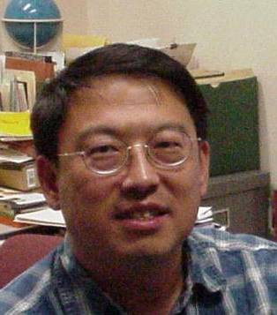

  0-7803-7231-X/01/$10.00/© 2002 IEEE

